Homework Lecture 4.
Name and ID :
Deadline 12-Mar-2025 23:00h
Presentation: Exercise 4 -Relational algebra and introduction to SQL.pdf
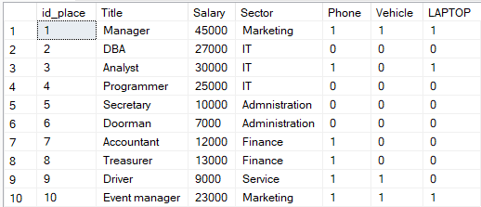

- From above table write relation algebra statement that will find maximum salary for IT sector
- Using selection, projection and renaming write how you will find who have laptop and vehicle and, in the output, to be columns work_place_id (id_place), title, department (sector).
- Write statements for the exercises from page 21 from the presentation.
- Write SQL statement for the points 1 and 2
- Write SQL queries for the exercise on page 33 and 34

Note: for all steps you need to provide screens.

Group 1 and Group 2 to send all the screenshots and files to zoran.gichevski@uacs.edu.mk
Group 3 send all the screenshots and files to igor.janchev@uacs.edu.mk

